Project Progress Report on
Mitigating Bias in Technical Recruitment through a Unified, Dynamic Assessment Platform
Submitted in partial fulfilment of the requirement for the award of the degree of

BACHELOR OF TECHNOLOGY IN
COMPUTER SCIENCE & ENGINEERING
with Artificial Intelligence and Machine Learning

Submitted by:

Akula Sai Santhosh Kumar | 2021791
Ashutosh Munindra Jha | 2021798
Rahul Negi | 2021823

Under the Guidance of Mr. Chitransh Bose Assistant Professor

Project Team ID: MP2025ML014 Project Progress Report No: 2


Department of Computer Science and Engineering Graphic Era (Deemed to be University)
Dehradun, Uttarakhand 2025-26



CANDIDATE’S DECLARATION
I/We hereby certify that the work which is being presented in the project progress report entitled “Mitigating Bias in Technical Recruitment through a Unified, Dynamic Assessment Platform” in partial fulfillment of the requirements for the award of the Degree of Bachelor of Technology in Computer Science and Engineering (with Artificial Intelligence and Machine Learning) in the Department of Computer Science and Engineering of the Graphic Era (Deemed to be University), Dehradun shall be carried out by the undersigned under the supervision of Mr. Chitransh Bose, Assistant Professor, Department of Computer Science and Engineering, Graphic Era (Deemed to be University), Dehradun.

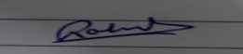
Akula Sai Santhosh Kumar | 2021791
Ashutosh Munindra Jha | 2021798
Rahul Negi | 2021823

The above mentioned students shall be working under the supervision of the undersigned on the “ Mitigating Bias in Technical Recruitment through a Unified, Dynamic Assessment Platform”

Supervisor Head of the Department

Examination

Name of the Examiners: Signature with Date
- ​
- ​

Table of Contents

Chapter No. | Description | Page No.
Chapter 1 | Introduction and Problem Statement | 1-2
Chapter 2 | Objectives | 3
Chapter 3 | Project Work Carried Out | 4-8
Chapter 4 | Future Work Plan | 9
Chapter 5 | Weekly Task | 10
 | References | 11

Chapter 1

Introduction and Problem Statement

Introduction
Hiring for tech roles is a massive headache because recruiters get buried under hundreds of applications for just one position, making manual screening a slow and subjective chore. The old ways of hiring struggle to show the whole picture of a candidate, often judging technical skills and personality traits separately. Today's automated tools aren't much better, as they usually focus on just one thing, like matching keywords on a resume or hosting a coding test. This scattered approach makes for a clumsy process for applicants and gives recruiters an incomplete view, making it hard to efficiently find the best person for the job. We really need a single, all-in-one platform that automates the screening process to provide a full, data-backed look at every single applicant.
This is where our project, the Mitigating Bias in Technical Recruitment through a Unified, Dynamic Assessment Platform, comes in. It’s an all-in-one AI system designed to smooth out the early steps of hiring by combining three key assessments into one simple workflow. First, it reads and understands a candidate's resume. The clever part is that it then uses that info to create personalized interview questions specifically for that applicant, making the screening more insightful. After that, it gives them an automated coding challenge to objectively test their technical skills. By putting all these pieces together, the platform gives recruiters a clear, simple dashboard with a single compatibility score, helping them make hiring decisions that are faster, smarter and far less biased.

Problem Statement
The main problem with tech recruiting is the lack of a smart, all-in-one system to properly size up candidates. This forces recruiters to waste countless hours manually screening resumes, leading to biased decisions and a broken hiring process that fails to measure both a person's coding abilities and their soft skills together.
This broken process creates three major problems:
    - Wasted Time: Recruiters and senior engineers get bogged down in repetitive screening work instead of talking with the best candidates.
    - Bias and Unfairness: Too often, hiring decisions are based on a "gut feeling" rather than on real data, which lets unconscious biases control the outcome.
    - An Incomplete Puzzle: Recruiters are left trying to patch together a candidate's profile from different sources, making it easy to misjudge them or miss their full potential.
Our project will fix this by building a single platform that automatically analyzes a resume, creates unique interview questions based on that resume and includes coding challenges. The goal is to deliver a complete, fair, and unbiased look to every candidate.

Chapter 2

Objectives

The primary objectives of the proposed work are as follows:

2.1 Automatically Read Resumes
Develop a system capable of automatically reading candidate resumes submitted in formats such as PDF or Word documents. The system extracts important information including technical skills, previous companies, job titles, and relevant experience to create a structured candidate profile for further evaluation.

2.2 Integrate a Technical Assessment

The system generates a tailored technical assessment consisting of multiple question types. Candidates attempt the assessment through a structured interface, and their responses are automatically evaluated by the system. The module then combines the scores from different assessment sections to produce a final result.

2.3 Create Custom Interviews
Develop an intelligent interview module that generates interview questions based on the information extracted from the candidate’s resume. The module conducts structured video interviews where candidates record responses, enabling the system to evaluate communication ability, response relevance, and clarity.

2.4 Produce a Single Score
Design a unified scoring engine that combines evaluation results from multiple stages including resume analysis, the technical coding assessment, and the video interview module. These results are aggregated to produce a single overall compatibility score for each candidate.
2.5 Design a User Dashboard
The User Dashboard is the central interface where candidates interact with the UTAP platform after logging in. It provides a structured view of the recruitment process and allows users to track and complete different stages of the assessment. The dashboard is designed to be simple and intuitive so candidates can easily navigate through the required tasks

2.6 Design a Recruiter Dashboard
Develop a user-friendly recruiter dashboard where hiring managers can view ranked candidate lists based on their final scores. The dashboard also provides detailed performance breakdowns for each candidate across all evaluation stages.

Chapter 3
Project Work Carried Out

This chapter documents all implementation progress of our project till date.

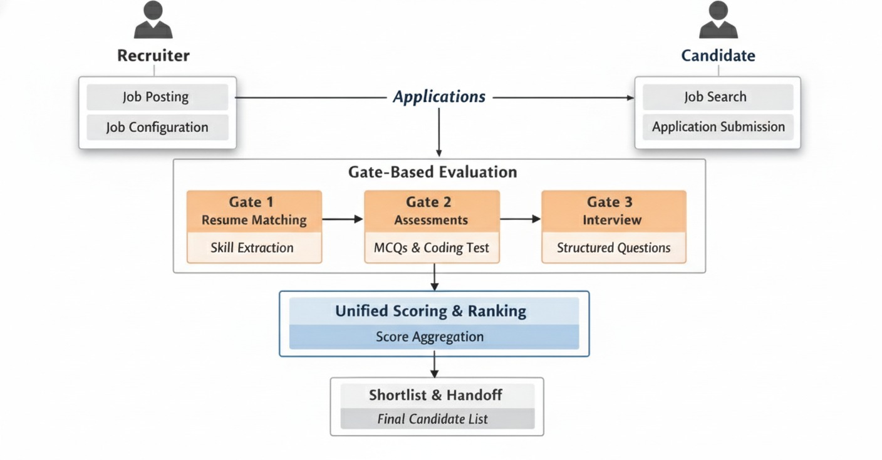

Fig 3.1 System Architecture of the Recruitment Mediation Platform

3.1 Backend Foundation

Work Completed:

- Developed the backend system using Django framework

- Implemented a custom user authentication system using AbstractBaseUser

- Designed role-based user management with three roles:

- Candidate

- Recruiter

- Admin

- Created core database models including:

- User

- Job

- Application

- Recruiter Profile

- Configured MySQL/SQLite database integration

- Implemented job posting functionality allowing recruiters to create and manage job listings

- Developed application management system enabling candidates to apply for jobs

- Integrated Django admin panel for platform management and monitoring.
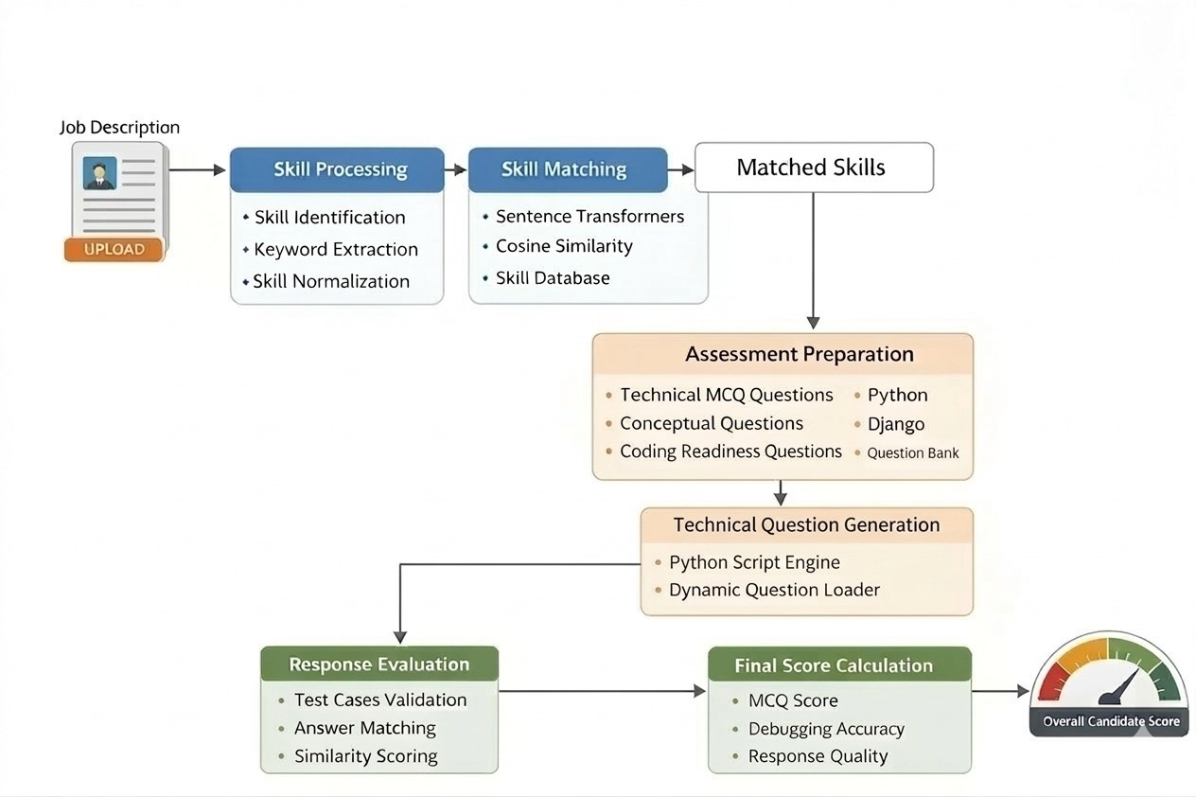
Fig 3.2 Resume Semantic Skill Evaluation Pipeline

3.2 Resume Upload Infrastructure

Work Completed:

- Configured MEDIA_URL and MEDIA_ROOT to store uploaded resume files

- Implemented resume upload functionality within the Application model

- Enabled candidates to submit resumes while applying for a job

- Configured file storage under the media/resumes directory

- Implemented backend validation to ensure proper resume file handling

- Linked uploaded resumes directly to candidate job applications

- Integrated resume storage with the application processing pipeline

3.3 Resume Text Extraction & Processing

Work Completed:

- Implemented resume text extraction using a dedicated resume processing engine

- Developed preprocessing utilities to clean and normalize resume text

- Implemented resume parsing to extract meaningful information from uploaded PDF files

- Designed modules to identify candidate skills and experience from extracted text

- Integrated NLP preprocessing techniques to improve text quality before analysis

- Stored extracted resume data in the database for further evaluation

- Built a modular resume evaluation engine consisting of:

- Text preprocessing

- Experience extraction

- Semantic skill matching

- Resume scoring

3.4 Assessment & Question Schema

Work Completed:

  - Integrated JSONField for storing options

  - Established one-to-many relationships

  - Registered models in admin panel

3.5 Dynamic Question Generator

Work Completed:

  - Designed centralized skill-to-question mapping (Question Bank)

  - Implemented logic for dynamic question selection

  - Ensured fallback logic for unknown skills

  - Integrated assessment creation + question generation pipeline

  - Saved all generated questions into database

Fig 3.3 Assessment Evaluation Pipeline

Fetch Assessment API

Work Completed:
  - Designed nested serializers for Assessment + Questions

  - Ensured secure output by hiding correct answers

  - Added API endpoint /api/my-assessment/

  - Implemented logic to fetch only the latest assessment for logged-in candidate

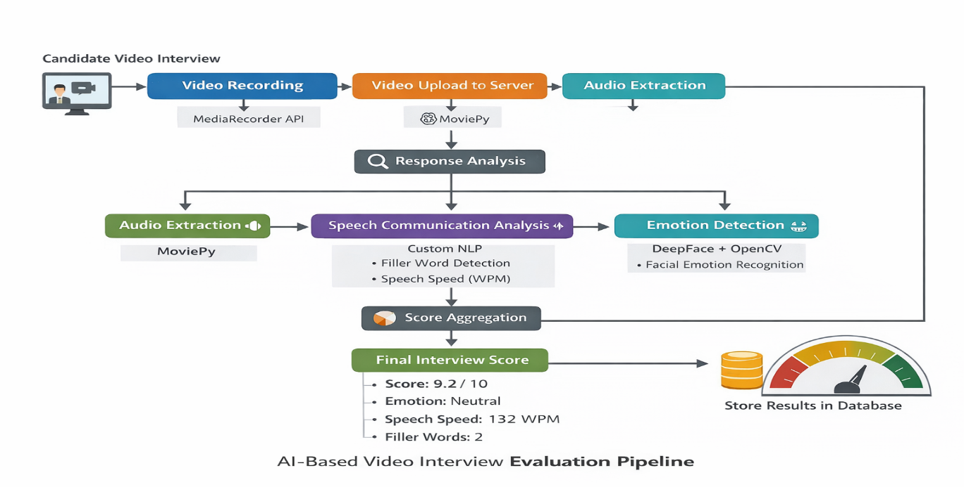

Structured Video Interview Evaluation Module

The structured video interview evaluation module was developed to automate the assessment of candidate communication and behavioral responses during the interview process. Unlike traditional interview systems, the proposed module integrates multiple artificial intelligence techniques to evaluate candidate responses objectively.

Work Completed:
- Video Interview Recording System.
- Audio Extraction from Video.
- Speech to text conversion.
- Semantic answer evaluation.
- Emotion Detection.
- Speech analysis metrics.

Chapter 4
Future Work Plan

The future work plan of our project are as follows:

Sl. No. | Work Description | Duration in Days
1 | Integration of all components | 5
2 | Real-Time Interview Feedback | 4
3 | Advanced Emotion and Behavior Analysis | 7
4 | Build a Unified Scoring Algorithm and Implementation | 4
5 | Refining Final UI | 2
6 | Testing, Debugging and Final Deployment | 3

Chapter 5
Weekly Task

The report of project work allocated by the supervisor is as follows:

Week  No. | Date:  From-To | Work Allocated | Work  Completed  (Yes/No) | Remarks | Guide  Signature
1 | 12-12-2025  To  18-12-2025 | Analysis of reviewer feedback and redesign planning for resume evaluation model
2 | 19-12-2025  To  25-12-2025 | Architecture redesign of resume evaluation engine and module restructuring
3 | 04-0102026  To  10-01-2026 | Development of experience analysis module and resume metadata processing
4 | 11-01-2026  To  18-01-2026 | Implementation of resume scoring logic and candidate evaluation parameters
5 | 19-01-2026  To  26-01-2026 | Integration of scoring engine with job application workflow
6 | 27-01-2026  To  04-02-2026 | Development of candidate ranking and shortlisting mechanism
7 | 05-02-2026  To  11-02-2026 | Integration of assessment and coding engine with candidate evaluation pipeline
8 | 12-02-2026  To  18-02-2026 | Testing and debugging of resume evaluation and candidate selection workflow
9 | 19-02-2026  To  22-02-2026 | Implementation of interview scheduling

References
- L. Chen et al., “Algorithmic Bias in Automated Hiring Systems,” ACM FAccT, 2022.
- H. Houser and M. Voss, “Bias Risks in AI-Driven Employment Decision Making,” Stanford Law Review, 2021.
- S. Gupta and R. Mehra, “Context-Aware Resume Entity Extraction Using Deep NLP Models,” IEEE TKDE, 2020.
- A. Roy and T. Banerjee, “Fairness Metrics in Machine-Assisted Recruitment,” Journal of Digital Hiring Analytics, 2021.
- M. Peterson and C. Jones, “Evaluating Objectivity in Automated Candidate Scoring,” ACM TOCE, 2022.
- Y. Kesim et al., “Transformer-Based Resume NER Performance Benchmarking,” arXiv, 2023.
- J. Narayanan, “Resume Parsing Using Machine Learning Models,” Semantic Scholar, 2022.
- A. Gupta and R. Sharma, “Semantic Relation Extraction for Professional Profiles,” Applied Computing Review, 2023.
- S. Lee and J. Kim, “Gaze and Expression Tracking for Interview Assessment,” IEEE FG, 2022.
- Hickman et al., “Automated Video Interview Assessment Validity,” PubMed, 2022.
- H. Verma and S. Kaur, “Secure Containerized Execution for Coding Evaluation,” IEEE Access, 2021.
- R. Just and A. Miller, “AI-Assisted Code Review Quality Metrics,” University of Washington, 2024.

